ReactJS-HOL

Create and Run Your First React App

Prerequisites (Install Only Once) Step 1: Install Node.js and npm
  - Visit: https://nodejs.org/en/download/
  - Download the LTS version (recommended for most users)
  - Install it (npm comes bundled with Node.js)

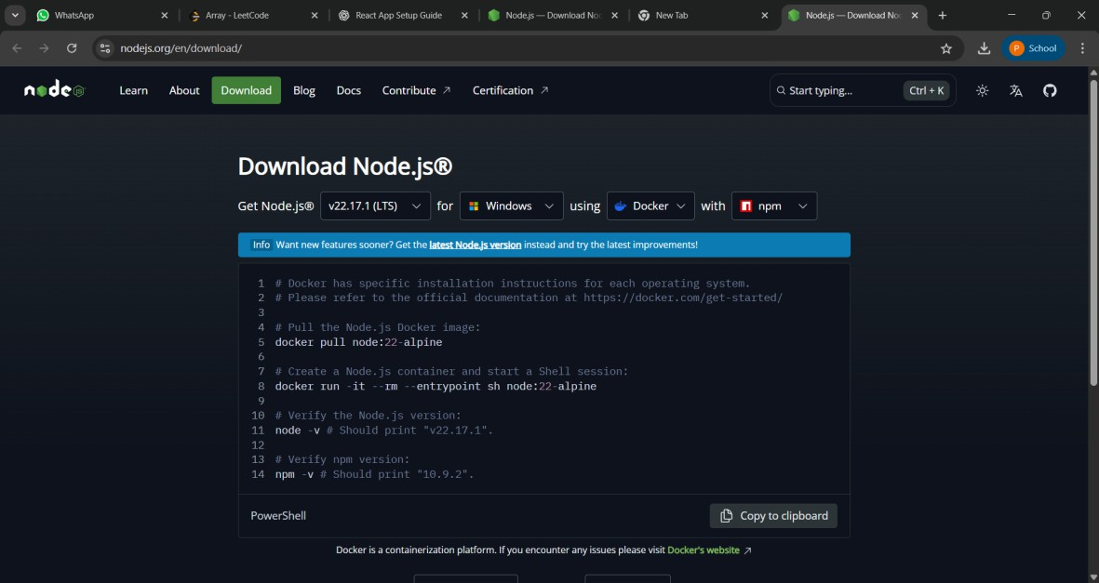

  - To confirm installation, open your terminal/command prompt: node -v
npm -v

React App Setup
Step 2: Install create-react-app (Only Once)
npm install -g create-react-app

Step 3: Create a new app named myfirstreact
npx create-react-app myfirstreact
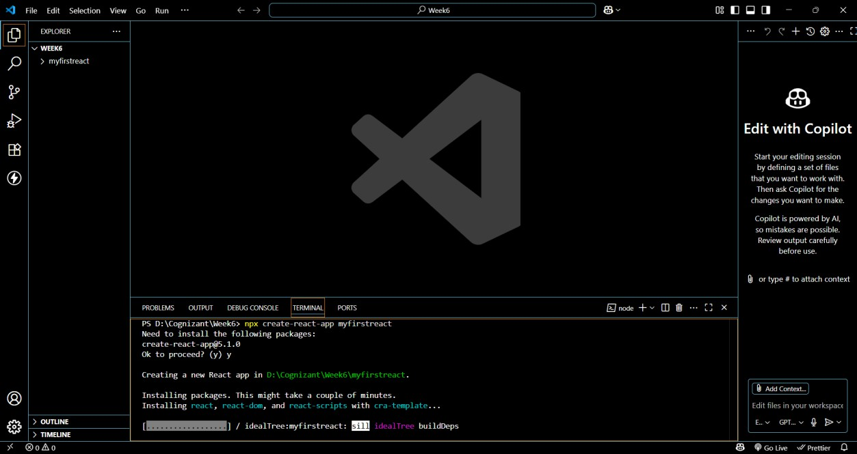

Step 4: Move into the project folder
cd myfirstreact
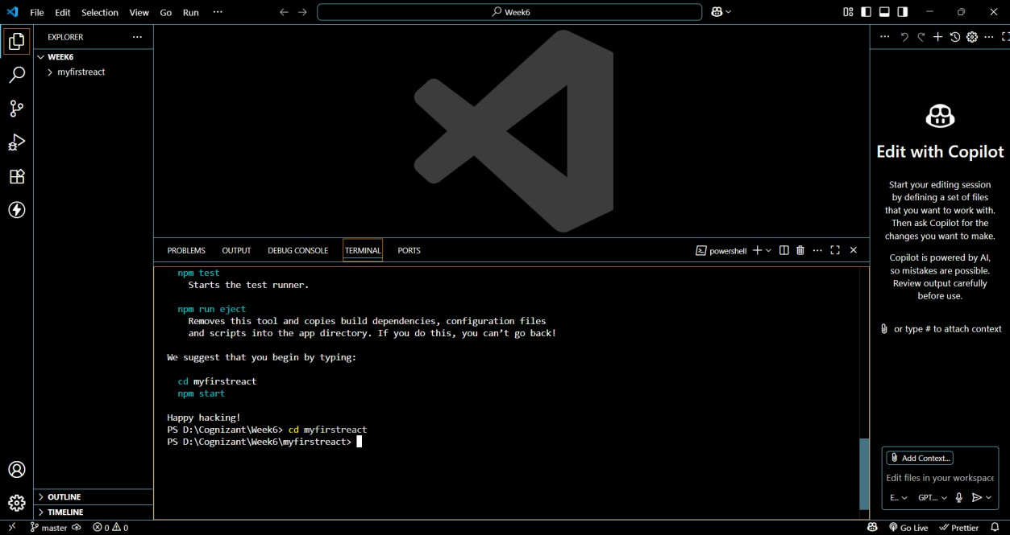

Modify the App Content Step 5: Open App.js
  - Go to: src > App.js
  - Delete all the existing code
  - Paste this simple code: import React from 'react';
function App() { return (
<div>
<h1>Welcome to the first session of React</h1>
</div>
);
}

export default App;
Existing App.js:
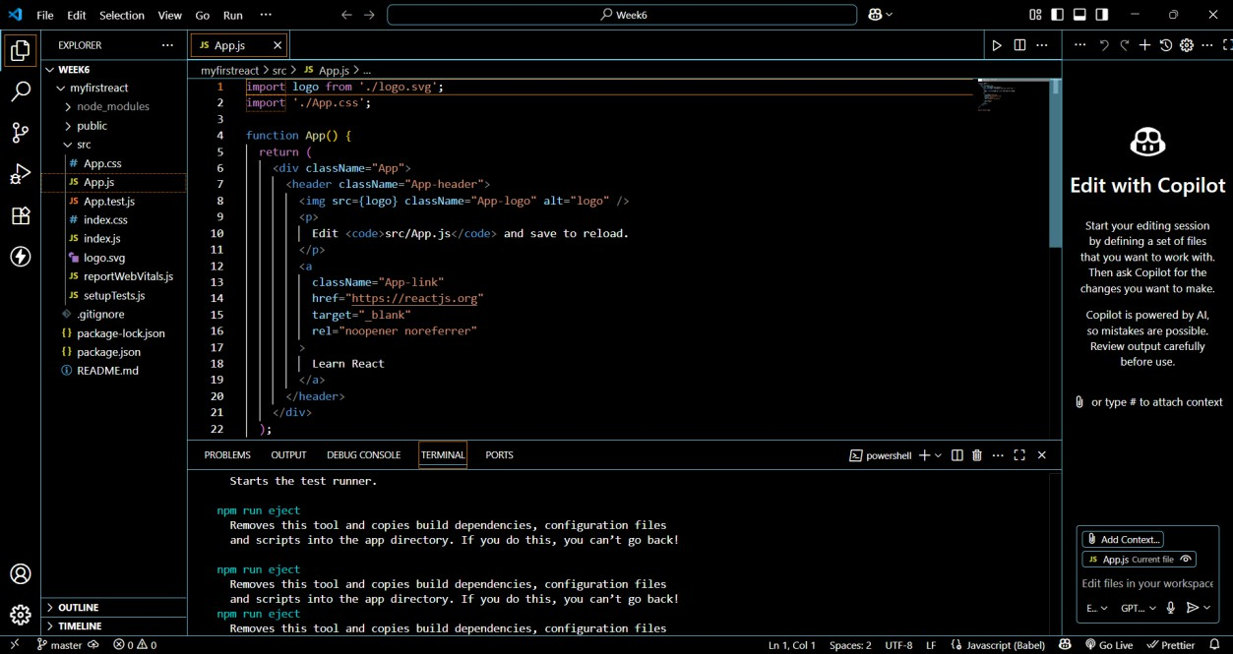

Modified App.js:
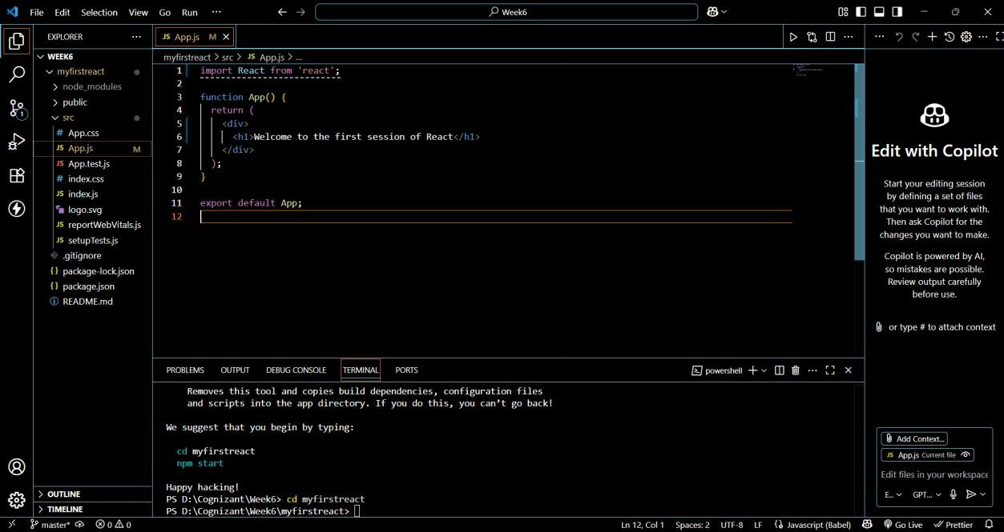

Run the Application
Step 7: Start the development server
In the terminal run:

npm start
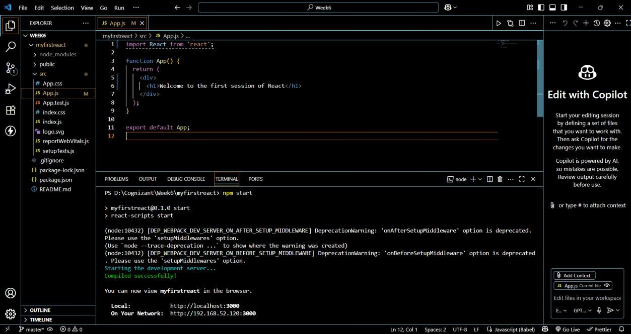

Step 8: View in Browser Open your browser and go to: http://localhost:3000
You should see:
Welcome to the first session of React
Result:

